May 21st, 2006
Leonie, Gavin, Nadine
Time for another letter. This is Leonie’s last weekend in Hong Kong; she flies back to Boston tomorrow. It has been good to have her here. I thought she would be spending the last few days here as the time she rented her room for expired on Friday. However, the hostel warden was not worried that she stayed the extra few days so she decided to stay there rather than having to lug all her stuff over here. Anyway, she will come here this afternoon to collect some things and have dinner, which will be mainly leftovers from the dinner she had the other night at the Jockey Club, hosted by her colleagues at the hospital.
Did quite a bit of exercise this past week, perhaps a little too much. Swam on three days. On Monday, actually swam 3 km, which I think is equal to the furthest I have swum at this pool. Did a total of 7 km for the week, which is more than the distance in previous weeks when I was swimming 5 days a week. As well as the swimming, did two days weights in the gym. However, as I am no doing much running nowadays, I am following the weights sessions by 12-minute runs.
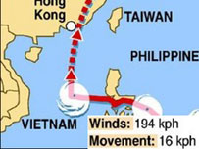
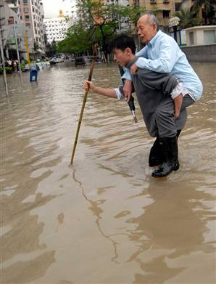
Last Monday, the first typhoon of the season was heading for HK. It was the strongest typhoon recorded for the month of May. It had previously crossed the Philippines and caused quite a bit of damage. It then headed due west towards Vietnam and then when it was due south of HK turned 90⁰ and headed straight for us. However, it later veered to the east and passed along the coast of China, causing a lot of flooding. But as far as HK was concerned, it was a bit of a fizzer.
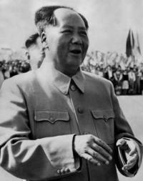
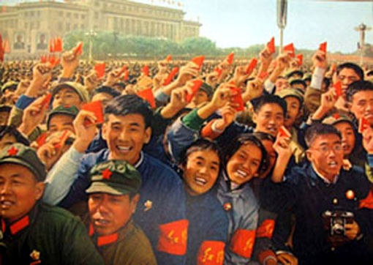
China has been in the news a bit. It was mentioned that the Cultural Revolution began last Tuesday 40 years ago, in 1966. This revolution was set in motion by Mao Zedong to bolster his flagging power and it was supposed to be a revolt against creeping capitalism in the country. But it got out of control with all the young ‘Red Guards’ going around the country destroying historical monuments and other buildings and persecuting and killing ‘capitalist roaders’ (as they were called), intellectuals and others. Millions died! The revolution lasted 10 years and only ended with the death of Mao in 1976. The photographs show Mao during those times and a rally of Red Guards in Beijing waving their little red books of Chairman Mao’s thoughts. However, there was no mention of the Cultural Revolution on the news in China as it is a black page in the communist party’s past and they did not want the issue mentioned as it could raise doubts as to their credibility, authority and ‘mandate of heaven.’
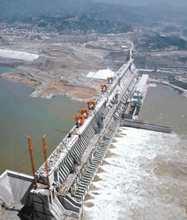
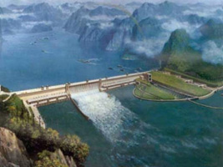
China announced that the main dam in Three Gorges project was completed yesterday. However, the turbines and generators have not yet been installed so it will be about a year before electricity is generated. There are many criticisms of the project relating to the 2 million people who had to be relocated, the corruption, and environmental concerns, e.g. the lake that is building up behind the dam is already badly polluted.


Did you hear about the NZ man, a double amputee, who reached the summit Mt. Everest the other day? Amazing! On the way up, he broke one of his artificial legs, but luckily, he was carrying a spare leg! I seem to remember how he lost his legs, which resulted from being trapped in an ice cave for 14 days in 1982 while climbing Mt Cook in NZ. He got severe frostbite then and had to have both legs amputated.

In Hong Kong, there is a Soccer 7s competition, which seems to have the same format as the Rugby 7s. Some European teams are here, including Manchester United and Aston Villa. Manchester United were knocked out of main competition and so will fight it out for the lesser trophy. On Friday, the Nearby Wetland Park officially opened. For a visual tour of the park, go to:

http://www.wetlandpark.com/en/exhibition/index.asp
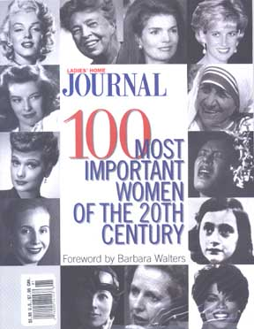
Finally, got your e-mail Gavin about Barbara Walter’s book on the 100 most important women of the 20th Century. I also wonder why she selected Jane Fonda, or “Hanoi Jane” as she was called during the Vietnam war. I looked on the Internet but could not find the reasons. (I did note that a majority of the women are American and many are entertainers!) The picture shows Jane Fonda manning a North Vietnamese anti-aircraft gun. Found on the Internet that in 1988, Fonda admitted to former American POWs and their families that she had some regrets, stating:
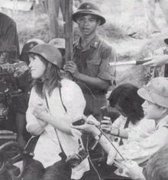
I would like to say something, not just to Vietnam veterans in New England, but to men who were in Vietnam, who I hurt, or whose pain I caused to deepen because of things that I said or did. I was trying to help end the killing and the war, but there were times when I was thoughtless and careless about it and I'm very sorry that I hurt them. And I want to apologize to them and their families. [...] I will go to my grave regretting the photograph of me in an anti-aircraft gun, which looks like I was trying to shoot at American planes. It hurt so many soldiers. It galvanized such hostility. It was the most horrible thing I could possibly have done. It was just thoughtless.

However, her regrets were limited to the photo appearance with the anti-aircraft gun, and that she was "proud" of her activism against other US actions in North Vietnam.
Was reading last year’s letter, and it said that the serial book “Hard Times” by Dickens arrived from Stanford. This year’s series of booklets is the Sherlock Holmes story “The Hound of the Baskervilles” by Arthur Conan-Doyle but it has not arrived yet.
The two semi-finals of the Super 14 competition were held this weekend. The Crusaders beat a SA side while the Wellington Hurricanes beat an Australian side. The final will be in Christchurch next Saturday.
That seems to be it for now. More than usual, with some ‘padding’ from the pictures.
Cheers

